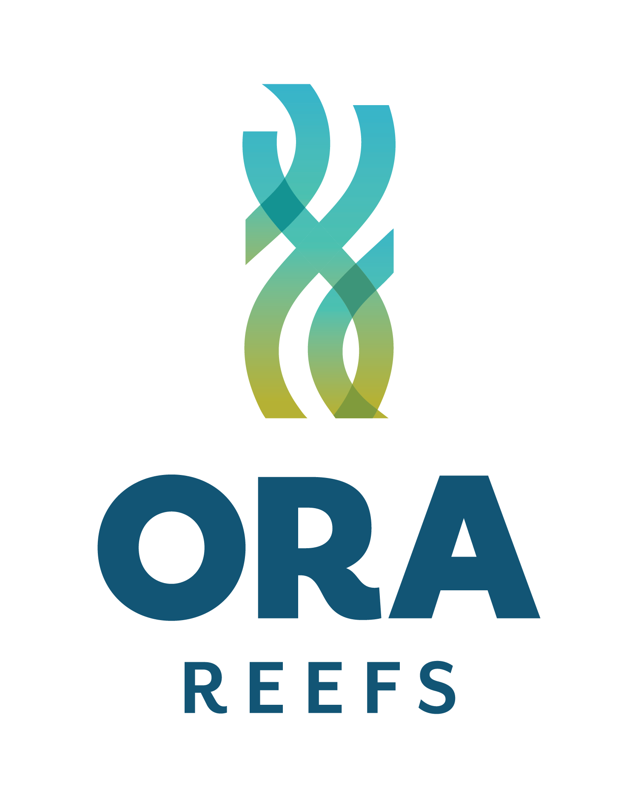
ORA Reefs - Pūtake Reef Pilot Trials

Working together to support healthy seabed’s in the Hauraki Gulf / Tīkapa Moana

Who we are?

ORA (Ocean Regeneration Aotearoa) is a charitable trust that brings together philanthropy, government, and private investment to create and deliver ocean-positive ventures.

ORA Reefs is one of these ventures. It focuses on restoring kelp forests and marine biodiversity in highly degraded areas of the Hauraki Gulf utilising proven, science-based restoration approaches.

Our work includes supporting kina removal, kelp reseeding, predator reintroduction, and - where natural habitat has been lost - carefully trialling artificial reefs.

What are Pūtake reefs?

Pūtake reefs are small, modular, low-profile reef units designed by ORA for placement on degraded soft-sediment seabeds where natural structure no longer exists.

They are:
- Made from durable, marine-safe materials
- Designed to sit low on the seabed
- Deployed as widely spaced individual units, not continuous reef structures

Over time, Pūtake reefs provide hard surfaces that allow shellfish, kelp, and other seabed life to naturally settle and grow, helping to rebuild habitat and biodiversity.

Why trial them?

In some parts of the Gulf, the seabed has lost natural structure due to historic dredging and sediment runoff from the land. This loss of physical complexity reduces habitat availability and limits the ecological functions that soft-sediment seabeds can support.

By reintroducing structure, Pūtake reef trials aim to create conditions that support habitat development, biodiversity, and ecosystem function over time, while co-existing with normal boating activity.

We have begun engagement with mana whenua and intend to continue this engagement.

What this looks like (indicative)?

Degraded seabed Low-profile Pūtake reef unit Natural colonisation over time
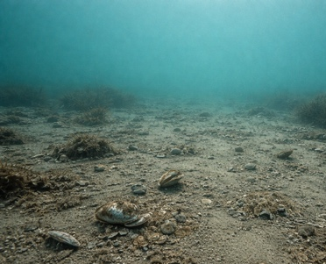
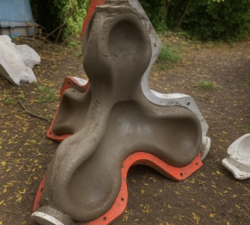
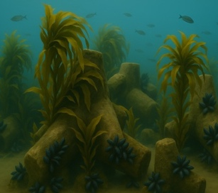

Location, Boating and Navigation considerations
- No sites have been selected at this stage
- We will avoid established anchoring areas
- Low-profile units deployed in small clusters
- Locations clearly mapped and shared before deployment
- Units can be lifted out during the pilot phase if required

Potential areas
We are exploring candidate areas that are within High Protection Areas (HPAs) and/or Seafloor Protection Areas (SPAs), where the intent is to reduce extractive pressure and support ecological recovery (including under-represented soft-sediment habitats). No deployment will occur until locations are confirmed through the consenting process and shared with stakeholders.

How the pilot works

Site selection Co-design sites Baseline surveys Deploy seed units Monitor & review

Want to know more or share feedback?


Rebecca Barclay-Cameron | Venture Projects Director, ORA

rebecca.barclay@envirostrat.co.nz

